Scotia Instrumentation
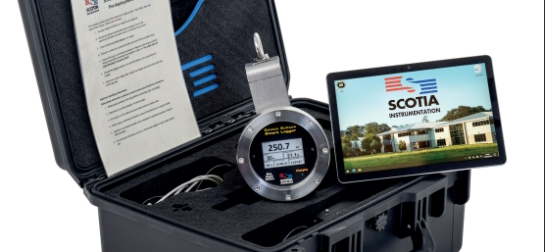
A pioneering player in measurement and subsea technology.
Project Objectives:
The primary objective was to manufacture a high-performance pressure enclosure for Scotia’s SSSL sensor, integrating two pressure transmitters for precise measurements of process pressure, depth, and temperature. W&H was entrusted with the task of manufacturing a robust and accurate instrument housing that could withstand extreme subsea conditions while meeting strict quality standards.

Approach:
Scotia Instrumentations' R&D team initiated the project to develop a pressure housing for their SSSL system by collaborating closely with W&H address the specific requirements and challenges of manufacturing a pressure housing rated to 1000M water depth. Drawing on their expertise in CNC and manufacturing techniques, W&H formulated a tailored manufacturing strategy to optimize precision, consistency, and efficiency to allow for later volume production.
Execution:
W&H's team of skilled engineers worked effectively to produce the pressure enclosure with exacting precision. Employing their manufacturing skills and stringent quality control measures, they ensured that each housing adhered to the highest industry standards. W&H’s skills in Stainless Steel manufacturing provided an enclosure with exceptional durability and protection against the harsh subsea environment.
Outcomes:
Woollard and Henry's seamless execution resulted in the successful delivery of the SSSL project. The precision-engineered pressure enclosure demonstrates superior accuracy, with pressure ranges of 0 - 1000 barg. The compact dimensions and robust build allows for easy deployment and reliable long-term subsea operation.

